
AMMAN ARAB UNIVERSITY
جامعة عمان العربـيــــــة
Faculty of IT
كلية تكنولوجيا المعلومات

Project title

Student Internship Recommendation System

Students:
Rama Khaldoun Hamdan
202210654

Supervisor:
Dr. Alaa Abuthawabeh

Amman – Jordan
2024/2025

Student Internship Recommendation System
1.Business Case:
1.1 Introduction/Background: The Student Internship Recommendation System aims to support university students in identifying internship opportunities that align with their academic background, skills, and personal preferences. The university currently lacks an automated solution that can intelligently match students with suitable companies, leading to inefficiencies and mismatches in internship placements.
1.2 Business Objective: The primary objective of this project is to design and implement a recommendation system that improves the quality and efficiency of internship placements. The system will use student data (skills, GPA, major, interests) and company listings to produce automated internship recommendations.
- Improving the match accuracy between students and internships.
- Reducing manual effort for students and university staff.
- Increasing successful internship placement rates.
- Providing a centralized and data-driven decision-making tool.
1.3 Current Situation and Problem / Opportunity Statement:
Currently, the internship search process is:
- Manual and time-consuming.
- Based on limited information.
- Lacking personalization.
- Dependent on students individual efforts and informal communication.
Problem:
Students often struggle to find suitable internships, and companies receive applicants who may not match their needs. University coordinators also spend significant time helping students manually.
Opportunity:
The system helps students find suitable internships more easily by analyzing their skills, background, and interests, then recommending opportunities that match them. This makes the internship search faster, simpler, and more accurate for everyone.

1.4 Critical Assumptions and Constraints:
Assumptions:
- Students will provide accurate and complete information about their skills and preferences.
- Companies will post internship opportunities regularly.
- The system will be accessible to all users with internet access.
- University IT infrastructure is sufficient to support the system.

Constrains:
- Limited project timeline (student academic project).
- Must comply with university data security and privacy policies.
- Limited budget for software tools and hosting.
- Availability of company internship data may affect recommendation accuracy.

1.5 Preliminary Project Requirements:

- Student profile creation (Name, Major, GPA, Skills, Preferences).
- Internship listing module for companies.
- Recommendation engine using content-based filtering.
- Administrator dashboard for system management.
- User-friendly interface for browsing and applying to internship.
- Analytics for tracking recommendations.
1.6 Budget Estimate and Financial Analysis:
Total Estimated Cost to build the system
120.000JD to 160.000JD
(development, system integration, database setup, security, servers)
Payback
- Saving 20,000–25,000 JOD per month
Seven-month payback period.
1.7 Schedule Estimate:
System fully implemented across all university departments within one year
(requirements → development → testing → rollout).
Requirement Analysis 2-3 Weeks
System design 2 Weeks
Development 6-8 Weeks
Testing 1-2 Weeks
Deployment 1 Week

1.8 Potential Risks
- Technical Risks – The system might not connect easily with the university’s existing systems.
- Operational Risks – High system usage during peak times may slow down performance.
- Financial Risks – The project might cost more if new features are added later.
- Data Risks – If students enter wrong or incomplete information, recommendations may not be accurate.

2.Project Charter:
2.1 Project Details
Title: Student Internship Recommendation System
Start Date: 25/11/2025
Projected Finish Date: 9/3/2027

2.2 Project Purpose / Justification:
The Student Internship Recommendation System is designed to improve the internship placement process by automatically matching students with suitable internship opportunities based on their skills, academic background, and personal preferences.
The current manual process is time-consuming, lacks accuracy, and requires continuous staff involvement.
This system will reduce workload, increase match accuracy, and support data-driven decision making for internship placements.
2.3 Project Objectives:
- Improve the accuracy of matching students with internship opportunities.
- Reduce manual work for students and university coordinators.
- Increase the overall number of successful internship placements.
- Provide a centralized, data-driven platform for managing internship recommendations.
- Allow companies to post internship listings easily and reliably.
2.4 Budget:
The project is expected to cost 120,000–160,000 JOD in the first year, covering development, system integration, database setup, security, and server infrastructure.
No additional annual costs are expected, as maintenance will be handled by existing IT staff.

2.5 PROJECT MANAGER:
The project will be managed by the University Internship Department in coordination with the IT Department, who will oversee development, testing, training, and rollout.
2.6 SUCCESS CRITERIA:
- The system completes recommendations with at least 85–90% match accuracy.
- Staff workload related to internship matching decreases by 40–50% within the first semester.
- At least 60% of students fully adopt the system in its first year.
- Companies actively post listings and interact through the system.
- The system achieves the projected 7-month payback period through cost savings and efficiency improvements.
- The platform remains stable and accessible during peak registration periods.
2.7 Approach:
- Follow SDLC steps (Requirements → Design → Development → Testing → Deployment).
- Use a modular system design for easier updates.
- Ensure student and company data is secure and protected.
- Build a recommendation engine to match students with internships.
- Provide basic training for users before launch.
- Monitor system performance and offer support after deployment.

3.Gantt Chart
The following Gantt chart illustrates the project timeline, outlining the key tasks, their durations, and the sequence in which they will be completed.
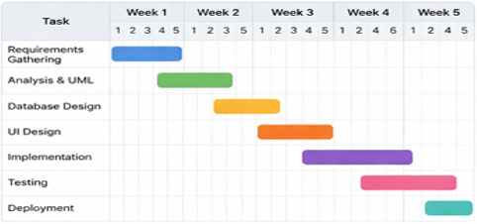
Figure 3.1: Gantt chart

4.SRS Requirements
4.1 Functional Requirements
FR1. The system shall allow students to create an account
FR2. The system shall match students based on skills and GPA
FR3. The system shall recommend internships
FR4. The system shall allow admins to manage users
4.2 Non-Functional Requirements
NFR1. The system should be easy to use
NFR2. The system should support multiple users at once
NFR3. The system must be secure (login authentication)
5.UseCase Diagram
The following use case diagram illustrates the interactions between users and the Student Internship Recommendation System, highlighting the main functionalities and system actors.
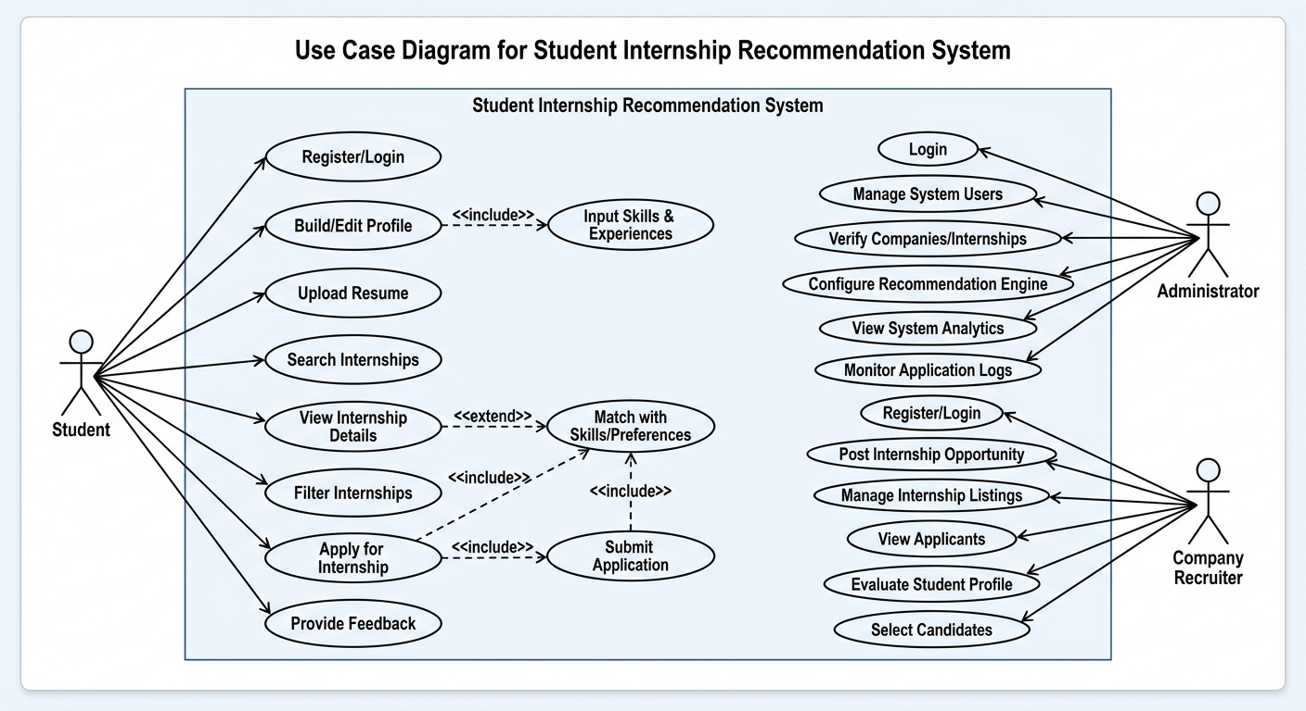
Figure 5.1: Use case diagram

6.Class Diagram
illustrates the Class Diagram of the system, modeling its core components using object-oriented principles. It defines the system’s structure through classes representing users, deliveries, activity logs, and dashboards, along with their attributes, methods, and interclass relationships such as associations and generalizations
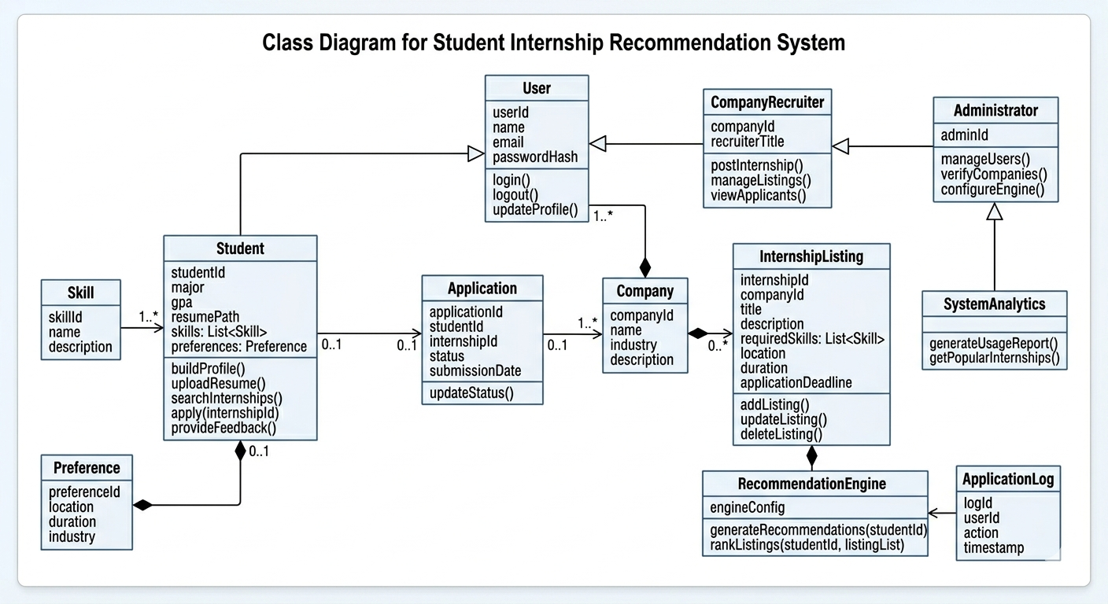
Figure 6.1: Class Diagram

7. User interface

The following section presents the user interface design of the system, illustrating the main screens and how users will interact with the application.

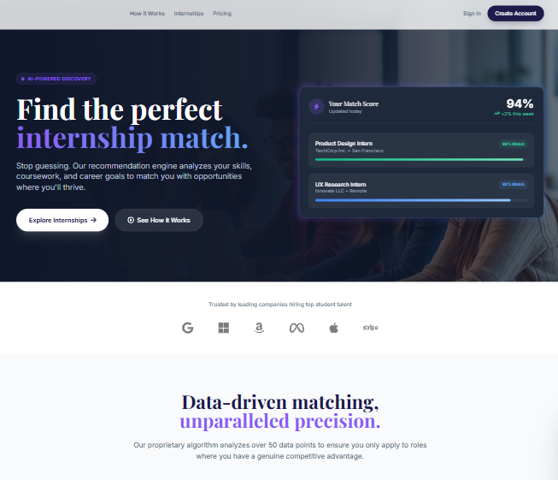
Figure 7.1: Main User Interface
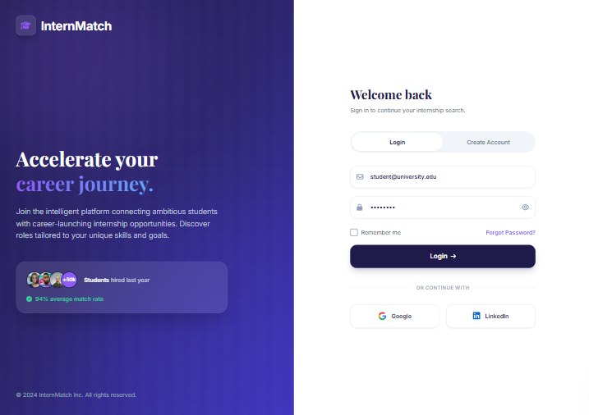
Figure 7.2: Login Interface
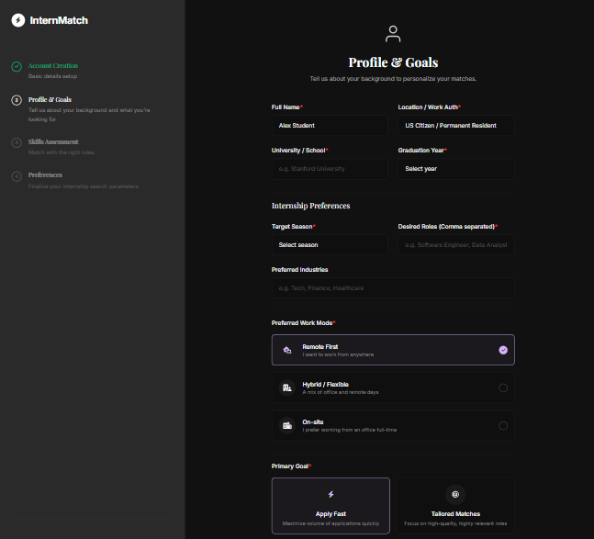
Figure 7.3: Internship search interface

